Criteria | Below Benchmark | Benchmark | Above Benchmark | Excellent
Genre  Conventions  /10 | 0 to 6 points  Lacks understanding and contains few or none of the required conventions of the writing task. | 7 to 7 points  Demonstrates general understanding and contains basic required conventions of the writing task. | 8 to 8 points  Demonstrates consideration of and follows most required conventions of the writing task. | 9 to 10 points  Demonstrates thorough consideration of and follows all required conventions of the writing task.
Style  /5 | 0 to 2 points  Lacks awareness of academic style, tone, and audience. | 3 to 3 points  Demonstrates basic awareness of academic style, tone, and audience. | 4 to 4 points  Demonstrates understanding of academic style, tone, and audience. | 5 to 5 points  Demonstrates a thorough understanding of academic style, tone, and audience.
Controlling  Idea/Thesis  /5 | 0 to 2 points  Incomplete or missing controlling idea/thesis. | 3 to 3 points  Uses a controlling idea/thesis that is not maintained throughout the essay | 4 to 4 points  Uses a clear controlling idea/thesis that is mostly maintained throughout the essay. | 5 to 5 points  Uses a clear controlling idea/thesis that is consistently maintained throughout the essay.
Content &  Development  /40 | 0 to 27 points  Lacks appropriate, relevant, and convincing content. Limited or no logical and coherent development of ideas. | 28 to 31 points  Uses some appropriate, relevant, and convincing content. Demonstrates basic logical and coherent development of ideas. | 32 to 35 points  Uses mostly appropriate, relevant, and convincing content. Demonstrates mostly logical and coherent development of ideas. | 36 to 40 points  Uses appropriate, relevant, and convincing content. Demonstrates logical and coherent development of all ideas.
Conclusion  /10 | 0 to 6 points  Limited or no reflection of student's informed evaluation of topic. Lacks implications and consequences of thesis. | 7 to 7 points  Somewhat reflects student's informed evaluation of topic. Contains basic implications and consequences of thesis. | 8 to 8 points  Reflects student's informed evaluation of topic. Implications and consequences of thesis are identified. | 9 to 10 points  Reflects student's informed evaluation of topic. Implications and consequences of thesis are presented.
Syntax &  Usage  /20 | 0 to 13 points  Many grammatical errors. Little or no use of complex sentence structures. Little or no use of academic vocabulary. Many spelling, capitalization, and/or punctuation errors. | 14 to 15 points  A number of grammatical errors. Some use of complex sentence structures. Some use of academic vocabulary. A number of spelling, capitalization, and/or punctuation errors. | 16 to 17 points  Very few grammatical errors. Use of complex sentence structures in general. Correct use of academic vocabulary. Very few spelling, capitalization, and/or punctuation errors. | 18 to 20 points  No grammatical errors. A variety of complex sentence structures throughout the essay. A variety of correctly used academic vocabulary throughout the essay. No spelling, capitalization, and/or punctuation errors.
APA Style and Use of Sources  /10 | 0 to 6 points  Attempts formatting requirements, including current APA referencing (in-text and Reference page) and contains many errors.  Attempts to demonstrate interpretation and integration of academic, credible, relevant sources to support ideas. | 7 to 7 points  Uses formatting requirements, including current APA referencing (in-text and Reference page) and contains a number of errors.  Demonstrates basic interpretation and integration of academic, credible, relevant sources to support ideas. | 8 to 8 points  Uses formatting requirements, including current APA referencing (in-text and Reference page) and contains few errors.  Demonstrates interpretation and integration of academic, credible, relevant sources to support ideas. | 9 to 10 points  Meets all formatting requirements, including current APA referencing (in-text and Reference page) and is error-free.  Demonstrates consistent interpretation and integration of academic, credible, relevant sources to support ideas.
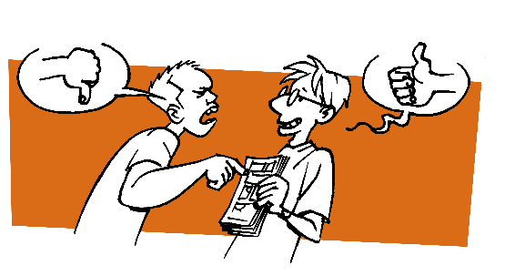
Total: Comments:

